Study Guide
Science Process, & What is Science

- What is science?
- What are the steps of the scientific process?
- What is the difference between an observation and an inference?
- What is a hypothesis?
- What is a control group?
- What are constants?
- What is the experimental group?
- What is the independent or test variable?
- What is the dependent or outcome variable?
- Which axis would you place the independent/test variable?
- Which axis would you place the dependent/outcome variable?
- What is the difference between quantitative and qualitative data?
- Why is peer review important?
- How many independent/test variables should the experimenter test?
- What makes an experiment controlled?
- How many trials should be done in order to make the experiment reliable and valid?
Mrs.Zona is growing roses in her yard but she is unhappy with number of flowers her plants are producing. She realizes her current fertilizer does not contain much phosphorus bearing nutrients (phosphates) and decides to try a high phosphate fertilizer to see if it increases the number of flowers her plants produce. Mrs. Zona conducts an experiment to test her hypothesis and follows the procedure below:

1. Divide the rose bushes into three groups.
2. One group continues to use the old fertilizer, another group will use the new fertilizer, and the third group will not use any fertilizer.
3. The plants all receive the same amount of sunlight and water.
4. Record the number of flowers in each group every two weeks for three months.
- What is the independent variable?
- What is the dependent variable?
- What is the control group?
- What are the constants?
- What type of graph would you use for graph the data?
- Write a testable hypothesis for the above scenario.
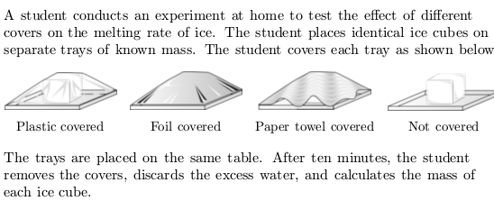

- What is the independent variable?

- What is the dependent variable?
- What is the control group?
- What are the constants?

