Unit 1 DIA Study Guide
Water, Macromolecules, Enzymes, and Activation Energy

- Describe the following properties of water.
  - Polarity
  - High Specific Heat
  - Cohesion
  - Adhesion
  - Universal solvent
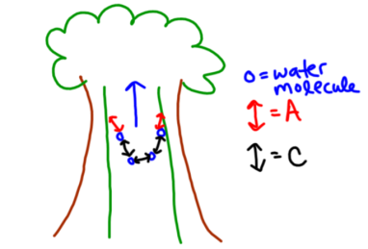
- Which property of water is shown below?

- Which property of water is shown below?
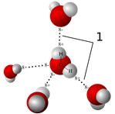
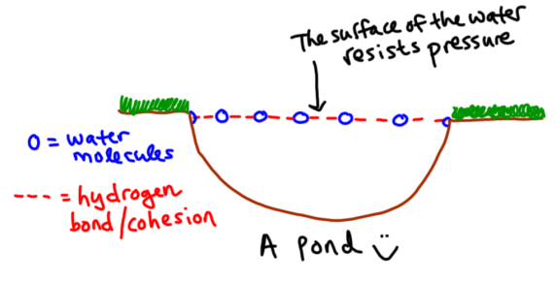
- Which property of water is shown below?

- Draw, label, and color the pH scale.

- Draw the structure of a carbohydrate (page 45)

- Draw a structure of a lipid (page 46 – Figure 2.13)

- Draw a structure of a protein (page 47 – Figure 2.15)

- Draw AND label a structure of a nucleic acid (page 230 – Visual Vocab)

- What is the function of carbohydrates?
- What is the function of lipids?

- What is the function of proteins?

- What are the building blocks of proteins?
- What is the function of nucleic acids?
- Give two examples of carbohydrates.
- Give two examples of lipids.
- Give two examples of proteins
- Give two examples of nucleic acids
- What is an enzyme?
- What macromolecule is an enzyme?
- What is a catalyst?
- What is activation energy?
- How does a catalyst affect the activation energy of a chemical reaction?
- How does an enzyme affect reaction rate?
- Suppose that the amino acids that make up an enzyme’s active site are changed. How might this change affect the enzyme?

- Some organisms live in a very acidic environment. How would that enzyme react if it were placed in a basic environment?

- What happens to enzyme action when the pH or temperature reaches extreme amounts?

- What does the term “denature” mean?

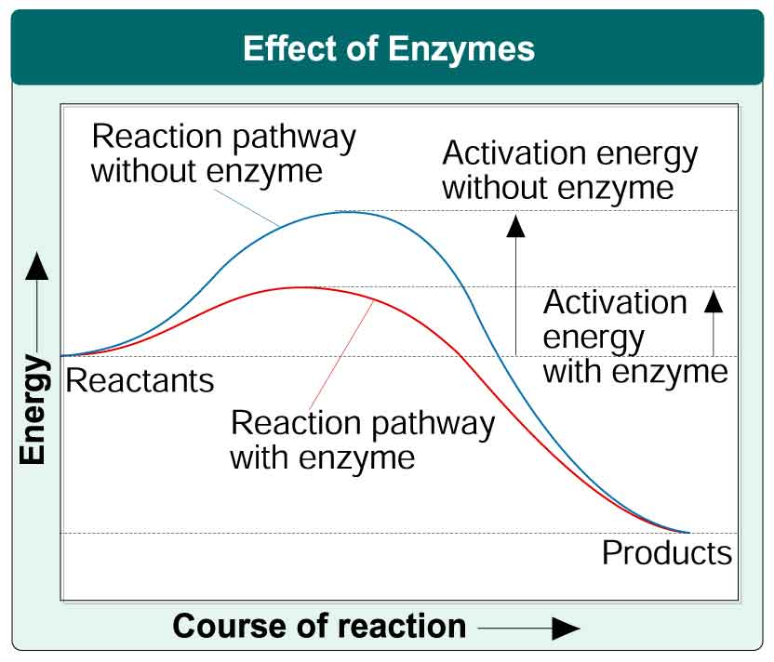
- Which line below do you want your enzymes to function at – Mark an X on the line.

