**Unit 2 DIA Study Guide**

**The Cell Theory, Cell Structure & Function**

1. 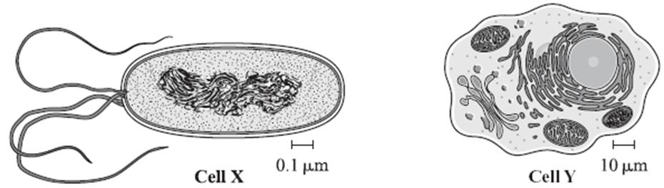What is the type of cell labeled X below? Cell Y?
2. Name the three parts of the cell theory.

|  |  |
| --- | --- |
| 3. | What part of the cell theory is shown in the model below? |
|  |  |
| 4. | According to the table below, which dye best determines whether cells are prokaryotic or eukaryotic? |

5. Cilia and flagella are structures attached to the cell membrane on some cells. What is the main function of both the cilia and the flagella in cells?

6. Which type of microscope would be the best choice to view the chloroplasts in a plant cell?

7. What type of microscope shows a three-dimensional image of a **specimen’s surface**? Specimens do not need to be cut into slices. This microscope would be used for examining the outer surface of a plant cell.

8. What type of microscope shows a two-dimensional image of a thin slice of the specimen? Specimens must be sliced in order to view. This microscope would be used to view a mitochondria’s **internal** structures in **greatest** detail.

9. A scientist notices that the specific cell she is studying contains a nucleus, lysosomes, a cell membrane, and a cell wall. How would you classify this cell?

**Prokaryotic or Eukaryotic** AND **Plant or Animal**

|  |
| --- |
| 10. Name the function of the organelles below. |
| |  |  | | --- | --- | | A. | Ribosome | | B. | Cell membrane | | C. | Chloroplast | | D. | Nucleus | |

11. Fill in the box with the appropriate information

Hooke

1665

First to identify cells and name them ______

Leeuwenhoekkk

1674

Observed cells in detail with new lenses

Schleidennn

1838

Schwann

1839

Virchow

1855

**Timeline for the Development of Cell Theory**

12. Some cell organelles, like the mitochondria, have large folded structures called cristae. What is the advantage of having a larger amount of these folded structures?



13. Label the organelles 1-4 in the above animal cell.

14. What is the function of organelle #2?

15. What is the function of organelle #4?

16. Name **three** differences that make plant cells different than animal cells.

17. Label the organelles 1-4 in the below plant cell.

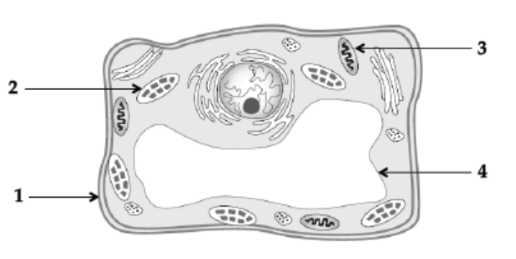

18. What is the function of organelle #1?

19. What is the function of organelle #2?

20. What is the function of organelle #3?

21. What is the function of organelle #4?

22. Which has more mitochondria…..muscle or fat? EXPLAIN

23. What is the only example of a prokaryotic cell in the world?

**Cell Membrane & Transport**

1. What is the function of the cell membrane?
2. Why is the cell membrane considered a “semi-permeable” barrier?
3. What is the cell membrane made up of?
4. What is the function of the proteins embedded in the cell membrane?
5. What is passive transport?
6. What is diffusion?
7. What is osmosis?
8. What is facilitated diffusion?
9. What is active transport?
10. What is endocytosis?
11. What is exocytosis?
12. What would happen to a red blood cell if it were placed in a hypertonic solution?
13. What would happen to a red blood cell when placed in a hypotonic solution?
14. What would happen to a red blood cell when placed in an isotonic solution?
15. Assume you had a cell membrane with only water molecules on one-side and water and glucose molecules on the other. In which direction would you expect the water molecules to move?
16. What plant organelle would prevent a plant cell from bursting when filling up with water?
17. Why are cells so small (surface area)?