Unit 3 DIAS Study Guide
Cell Reproduction (Mitosis/Meiosis)

- Fill in the table below with the correct information.
 | Asexual Reproduction | Sexual Reproduction
# of cells at the start
# of cells at the end
Does this process use gametes?
Is there genetic variety with this process?
What is the purpose of this process?
Example:

- If plant A is produced asexually from plant B, and plant A has 50 chromosomes, how many chromosomes does plant B have?

- What is the cell called that is produced sexually?
- What type of cells does mitosis produce?
- What is the purpose of mitosis?

- What are the four phases of mitosis?

M =
G1 =
G2 =
S =

- For each phase, describe what happens:

- Interphase:
- Prophase:
- Metaphase:
- Anaphase:
- Telophase:
- Cytokinesis:
- Why is it important that DNA replication happens?
- The process that forms a zygote is called?
- What type of cells are made by the process meiosis?
- If a cell entering meiosis has 12 chromosomes, each of the resulting cells will have how many chromosomes?

- What is the other word for sex cells?
- How many chromosomes does each human sex cell have?
- Arrange the phases of the cell cycle in the correct order.
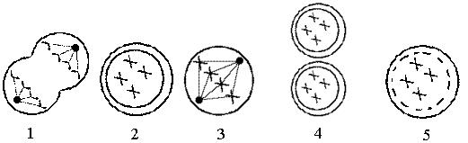

- The picture below shows a process that occurs during meiosis. This process creates new traits that can be inherited by the offspring. What is this process called _______________ ______________ (2 words)

- What is the process below and what kind of cells does it produce?

- Which row in the chart below indicates the correct process for each event indicated?
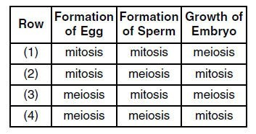

- In Mitosis, how many times the cell divide?_________. How many cells result?____________
What type of cells are produced in mitosis?_________________________________________

- In Meiosis, how many times the cell divide?_________. How many cells result?____________
What type of cells are produced in meiosis?________________________________________

Photosynthesis & Cellular Respiration
- What is photosynthesis?
- What is the equation for photosynthesis?
- What are the reactants of photosynthesis?
- What are the products of photosynthesis?
- In what organelle does photosynthesis take place?
- What is cellular respiration?
- What is the equation for cellular respiration?
- What are the reactants of cellular respiration?
- What are the products of cellular respiration?
- In what organelle does cellular respiration take place?
- What is the difference between aerobic and anaerobic respiration?
- What is ATP?
- How are photosynthesis and cellular respiration related?
- The energy for all organisms begins with the ____________.
- Do plants have mitochondria?
- The diagram below shows the relationship between photosynthesis and cellular respiration and the organelles in which they occur. Describe how photosynthesis and cellular respiration are interrelated?
