

**Dear Students and Families,**

Please sign up for Remind for text or email message reminders of quizzes, tests, project due dates, etc. Text code to 81010. Period 2 & 6 is @bstbio. Period 1 code is @bstbiohon. Reply to response with your full name to complete sign up if prompted. If you need to send a message to me, please email to [jarretts@burnsscitech.org](mailto:jarretts@burnsscitech.org) or use Powerschool.

**What do I need?**

* A 3 subject, college ruled (**8 ½ X 11 inch**) spiral notebook. The size is important for all their papers to fit without having to cut
* Pens or Pencils
* Index cards
* Be prepared with supplies and to work EVERYDAY- for class.

**What will we be doing in class?**

* Each day when you enter you should get out your planner, Interactive Science Notebook (ISN), pencil/pen. Phones and earbuds should be put away unless being used for a specific teacher assigned task.
* Look at the overhead projector to see if there are any handouts to be picked up or Bell Assignment to do. You will need your ISN EVERYDAY.

**How will I be graded?**

* **FINAL GRADE: Formative Assessment**

**(ISN quizzes/Classwork/Informal Labs) = 40%**

**Summative Assessment**

**(Projects/Lab Reports/Topic Quizzes/DIAs (Tests)) = 60%**

**Test Remediation:** Students are welcome to remediate Unit they did earn mastery on by completing test corrections to improve their score. This must be done **before** the next DIA.

**\*\***All missing formative assignments can be made up anytime **before** the DIA. Work not turned in by this deadline will remain a zero.

**What if I am absent or late?**

* You should come to class on time and be ready to participate. If you are not present (body or mind), there will be missed information that may lead to misunderstandings and lower grades.
* If you miss class, you may get your assignments in the following ways:

1. Go to Canvas.
2. Look at Mrs. Jarrett’s ISN for the page you are missing or get the directions from another student’s ISN.
3. Go to the “Were you Absent?” bin and look under the day you were absent for any handouts that may have been passed out. Note: No handouts does not mean there was not an assignment, we work every day.

* If something was covered while you were out, you are not excused from it. It **will** be on the test!
* If you are absent for a test, you will be expected to make it up **the day you return**.

Estimated Schedule of Biology Topics- State End of Course (EOC) Exam will be administered in early May.

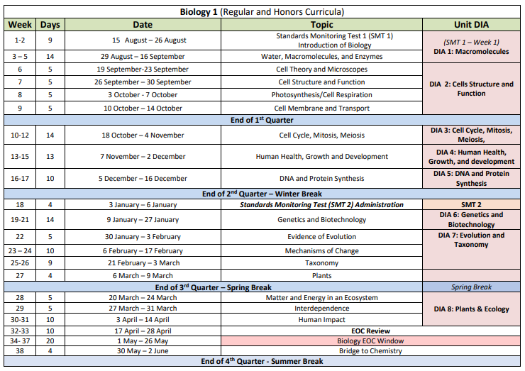

This biology course is required to graduate from high school. The grades from each of the four quarters will be used, along with the EOC score to determine a student’s overall grade for the course and to determine if credit was earned. The EOC is worth 30% of the overall grade for the year. Students are encouraged to stay on track with the content and seek help if they are having difficulty.



Parent Page: Please cut at dotted line and keep the top portion for your record and return the bottom completed and signed. Thank you.

Additional Information:

A copy of these class guidelines can be found on Powerschool/Schoology and Canvas. I encourage you to bookmark it for quick access. The course will also use Canvas for some assignments, quizzes, etc. These sites should be used regularly by the students to access Gradebook, short video clips, description of what was done in class that day, copies of handouts, links to EOC exam review, etc. My email is [jarretts@burnsscitech.org](mailto:jarretts@burnsscitech.org), please contact me with any questions or concerns. I also use Remind app to send important information (see codes on first page).

If you would like to know how your student is doing in class, not only can you check Gradebook but also ask to see their ISN. Effort shown on ISN is usually related the understanding of concepts. Pages should have date, be complete, neat, have good written explanations of concepts, labeled diagrams or drawings should have color, notes should legible. Students should be using their ISN to review all year. It will be especially important at the end of year when preparing for the End of Course Exam (State EOC). By checking their ISN you get a good idea of your student’s progress and if they may be struggling. Your student will see that you are aware of what is going on in class and opens up communication with your student.

Please print your name and sign below and give me your current contact information. In most cases I will use Powerschool to contact you. If you receive an email/message from me, please let me know you’ve received it.

**PLEASE CUT ALONG LINE, KEEP THE TOP AND RETURN THE BOTTOM**

*---------------------------------------------------------------------------------------------------------------------------------*

***After reading these expectations, we understand that the grade received in this class reflects the student’s knowledge of biology content.***

*Student Name (Print) _________________________________________________*

*Student Signature______________________________________________*

*Parent Name (Print) ___________________________________________________*

*Parent Signature________________________________________________*

*Preferred Contact Information:*

*Phone_________________________________________________________*

*Email_________________________________________________________*

*At home, do you have reliable: Computer: Yes / No Internet: Yes / No Printer: Yes / No* ***please circle******yes or no***