Name: ________________________________________ Date: _______________________ Period: ______

Codominance, Incomplete Dominance, Blood Types, Sex Linked Traits Worksheet

Codominance:

1. MC900417384[1]In some chickens, the gene for feather color is controlled by codominance. The allele for black feathers (B) is codominant with the allele for white feathers (W). The heterozygous phenotype is known as Erminette (BW), a mixture of black and white feathers.
   1. What is the genotype for **black** chickens? _____
   2. What is the genotype for **white** chickens? _____
   3. What is the genotype for **erminette** chickens? _____
2. Fill in the Punnett square below by crossing **two erminette** chickens.

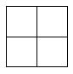

* 1. Parent genotypes: ____________ & ____________
  2. Probability they will have a **black** chick: _____ %
  3. Probability that they will have a **white** chick: _____ %
  4. Probability that they will have an **erminette** chick: _____ %

1. Fill in the Punnett square below by crossing a **black** chicken and a **white** chicken.
   1. Parent genotypes: ____________ & ____________
   2. Probability they will have a **black** chick: _____ %
   3. Probability that they will have a **white** chick: _____ %
   4. Probability that they will have an **erminette** chick: _____ %
2. In dogs, gum coloration is co-dominant, with black exerting dominance over pink. You have a spotted gummed Labrador retriever who has just had 8 pups. Four of the pups have spotted like your dog, and 4 have pink gums. What is the likely phenotype of the sneaky neighbor dog?
3. Cross two MEDIUM height plants. (SHOW WORK)

Incomplete Dominance:

1. 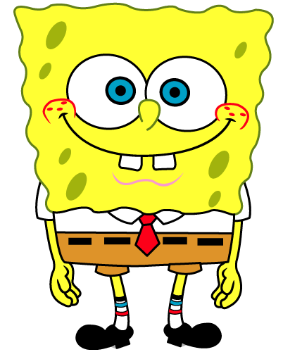SpongeBob loves growing flowers for his pal Sandy! Her favorite flowers, Poofkins, are found in red, blue and purple. The gene for red flower color (R) shows incomplete dominance with the gene for blue flower color (B). The heterozygous phenotype is purple flowers (RB).
2. What is the genotype for **red** flowers? _____
3. What is the genotype for **blue** flowers? _____
4. What is the genotype for **purple** flowers? _____

7. Fill in the Punnett square below by crossing a Poofkin with **red** flowers, with a Poofkin with **blue** flowers.



a. Parent genotypes: ____________ & ____________

1. Probability offspring will have **red** flowers: _____ %
2. Probability offspring will have **blue** flowers: _____ %
3. Probability offspring will have **purple** flowers: _____ %

8. Fill in the Punnett square below by crossing two Poofkins with **purple** flowers.

a. Parent genotypes: ____________ & ____________

1. Probability offspring will have **red** flowers: _____ %
2. Probability offspring will have **blue** flowers: _____ %
3. Probability offspring will have **purple** flowers: _____ %

9. Show the genotypes of the offspring of an F1 generation cross between two ‘roan’ (reddish brown) colored cattle RR = Red, Rr = Roan, rr = white

Multiple Alleles:

1. Blood type is controlled by three alleles: A, B & O. A & B are codominant. O is recessive.
2. If you have **type A** blood, what are your possible genotypes? __________
3. If you have **type B** blood, what are your possible genotypes? __________
4. If you have **type AB** blood, what must your genotype be? __________
5. If you have **type O** blood, what must your genotype be? __________
6. A man with **type AB** blood is married to a woman who also has **type AB** blood. Fill in the Punnett square for this cross below.



1. Parent genotypes: ____________ & ____________
2. Which blood types could their children have?

_____________________________________________________

1. List the percentage of offspring that are expected to have each blood type:
   * 1. AB blood: _____%
     2. A blood: _____%
     3. B blood: _____%
     4. O blood: _____%
2. A man who is **homozygous for type B** blood is married to a woman who has **type O** blood. Fill in the Punnett square for this cross below.



1. Parent genotypes: ____________ & ____________
2. Which blood types could their children have?

_____________________________________________________

1. List the percentage of offspring that are expected to have each blood type:
   * 1. AB blood: _____%
     2. A blood: _____%
     3. B blood: _____%
     4. O blood: _____%
2. A baby switch-up happened at a hospital. Both parents have a suspicion that this is not their baby. The mother has **type O** blood and the father has **type AB**. Their baby has blood **type B**. Fill in the Punnett square below using the parents’ genotypes.
3. Mother’s Genotype: _____
4. Father’s Genotype: _____
5. Babies Genotype: _____ or _____
6. Can you tell if this baby was switched based upon its blood type? Explain.

__________________________________________________________________________________

Sex Linked Traits:

* As with any sex-linked trait, Male Pattern Baldness is more prevalent in males.

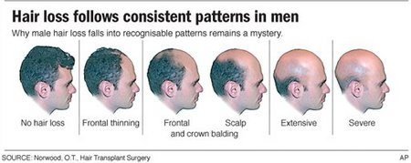

1. Cross a Female who is a Carrier for pattern baldness with a Male who has the gene for pattern baldness

**Duchennes Muscular Dystrophy**

Is a sex linked genetic disorder that results in muscle degeneration and eventual death 🡪 caused by a mutation in the dystrophin gene, the largest gene located on the human [X chromsome](http://en.wikipedia.org/wiki/X_chromosome) which codes for the [protein](http://en.wikipedia.org/wiki/Protein) dystrophin, an important structural component within muscle tissue that provides structural stability to the [dystroglycan complex](http://en.wikipedia.org/wiki/Dystroglycan_complex) (DGC) of the [cell membrane](http://en.wikipedia.org/wiki/Cell_membrane).

1. Cross a carrier with a male who is normal for the dystrophin gene and give the Genotype & Phenotype.