Create a Scatter Chart

So, how did we create this scatter chart? The following procedure will help you create a scatter chart.
- Copy the example worksheet data into a blank worksheet in excel.
Daily Rainfall | Particulate
4.1 | 122
4.3 | 117
5.7 | 112
5.4 | 114
5.9 | 110
5 | 114
3.6 | 128
1.9 | 137
7.3 | 104

- Select the data that you want to plot in the scatter chart.

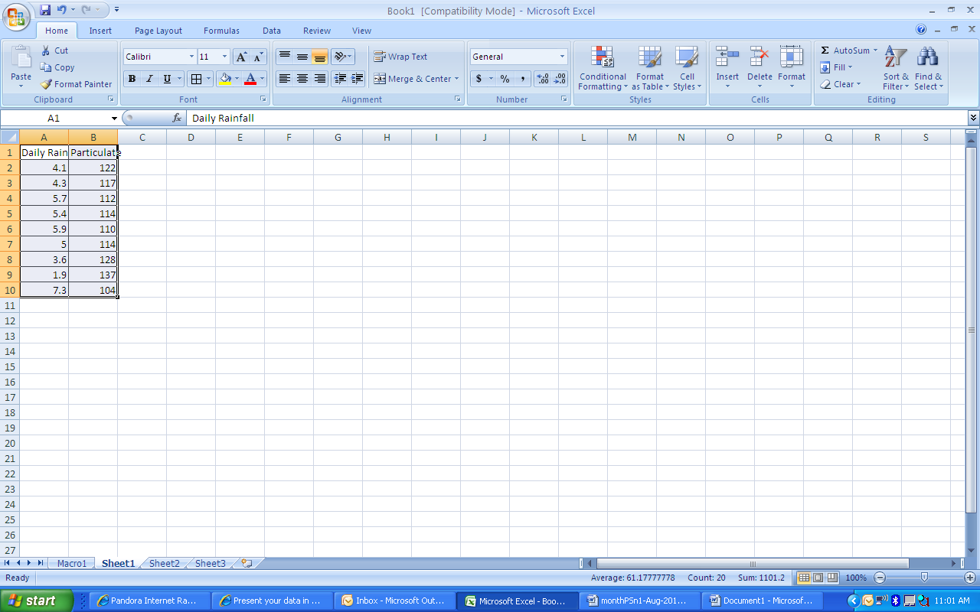

- On the Insert tab, in the Charts group click Scatter.

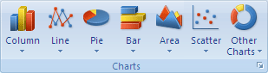

- Click Scatter with only Markers.
TIP – You can rest the mouse on any chart type to see its name.

- Click the chart area of the chart.
This displays the Chart Tools, adding the Design, Layout, and Format tabs.

- On the Design tab, in the Chart Styles group, click the chart style you want to use.
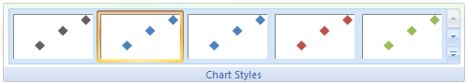

- Click the chart title and then type the text that you want.
TIP – Pick a descriptive title, such as Particulate Levels in Rainfall

- To reduce the size of the chart title, right click the title, and then enter the size that you want in the Font Size box in the shortcut menu.
TIP – We recommend using size 14.

- Click the chart area of the chart.

- On the Layout tab, in the Labels group, click Axis Titles, and then do the following:

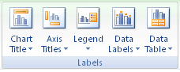

-To add a horizontal axis title, click Primary Horizontal Axis Title, and then click Title Below Axis.

-To add a vertical axis title, click Primary Vertical Axis Title, and then click the type of vertical axis title that you want.
TIP – I recommend Rotated Title.

-Click each title, type the text that you want, and then press ENTER.
TIP – Axis headings are typically the heading at the top of you excel columns. The first column is your X axis and second column is your Y axis.

- Click the plot area of the chart, or select Plot Area from a list of chart elements (Layout tab, Current Selection group, Chart Elements box).

- On the Format tab, in the Shape Styles group, click the More button , and then click the effect that you want to use.
Tip For our scatter chart, we used the Subtle Effect - Accent 3.
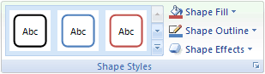
- Click the chart area of the chart.
- On the Format tab, in the Shape Styles group, click the More button , and then click the effect that you want to use.
Tip We typically use the Subtle Effect - Accent 1.

- If you want to use theme colors different from the default theme that is applied to your workbook, do the following:

- On the Page Layout tab, in the Themes group, click Themes.
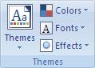
- Under Built-in, click the theme that you want to use.
Tip We typically use the Office theme.
Add a Trend Line
- Right click on any data point on the graph.

- Choose add a linear trend line and click enter.
When you are finished call your teacher over to check your graph
.

