DIA Review
Topic: Scientific Process
Station 1

Identify the following parts to the experiment below:

A student wants to know if her rose plants (normally grown in shaded areas) will be able to grow under full sunlight. She plants 10 roses of the same kind in a shaded area of her yard. She plants 10 more roses in an area of her yard that receives full sun exposure. She waters them with equal amounts of water three times a week for 6 weeks at the same time each day. After six weeks, she measures the heights of the plants.

- Hypothesis (if… then)___________________________________________________________

- Control Group ________________________________________________________________

- Experimental Group ___________________________________________________________

- Independent/Test Variable_______________________________________________________

- Dependent/Outcome Variable_____________________________________________________

- Constants/Controls _____________________________________________________________

DIA Review
Topic: Scientific Process
Station 2

7. A scientist hypothesizes the temperature at which an alligator's egg is incubated will determine whether the alligator will be male or female. The independent variable is
A) The incubator
B) The temperature
C) The male alligators
D) The gender of the alligator

8. A scientist hypothesizes the temperature at which an alligator's egg is incubated will determine whether the alligator will be male or female. The dependent variable is
A) The temperature
B) The incubator
C) The size of the baby alligators
D) The gender of the baby alligators

DIA Review
Topic: Scientific Process
Station 3

9. In an experiment, the one variable that is changed is called the
A) Controlled variable
B) Independent variable
C) Dependent variable
D) Experimental variable

10. In an experiment, the factor that we measure is called the
A) Independent variable
B) Controlled variable
C) Dependent variable
D) Conclusion

DIA Review
Topic: Scientific Process
Station 4

11. All the things in an experiment that must be the same to make it valid are called

A) Independent variables
B) Controlled experiments
C) Dependent variables
D) Controlled variables or constants

12. A scientist who wants to study the affects of fertilizer on plants sets up an experiment. Plant A gets no fertilizer, Plant B gets 5 mg. of fertilizer each day, and Plant C gets 10mg. of fertilizer each day. Which plant is the control group?

A) Plant A
B) Plant C
C) All of them
D) Plant B

DIA Review
Topic: Scientific Process
Station 5

- The best graph to use if I want to compare the price of six different cars would be a

A) Bar graph
B) Data table
C) Line graph
D) Pie graph

- Why is it important to conduct scientific tests more than one time?

- To make sure there is no bias
- To ensure the experiment is valid
- All the above

DIA Review
Topic: Scientific Process
Station 6

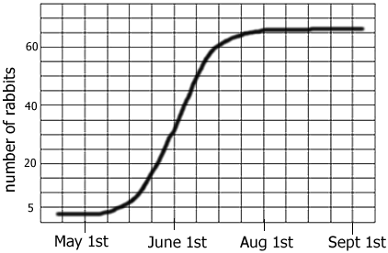

On the graph itself, what is the:

15. X axis?
16. Y axis?
17. Independent Variable
18. Dependent Variable?
19. What is the graph “saying”?_

DIA Review
Topic: Properties of Water
Station 7

20. The unique attractive forces that keep molecules of water together are called:

- Strong forces.
- Adhesion.
- Hydrogen bonds.
- Weak nuclear forces.

21. The high heat capacity of water allows it to:

- Form additional hydrogen bonds
- Absorb large amounts of heat energy before the temperature changes
- Boil at higher temperatures than many liquids
- B and C

DIA Review
Topic: Properties of Water
Station 8

22. Water molecules are polar, with the

- Oxygen and hydrogen sides being slightly positive.
- Oxygen and hydrogen sides being slightly negative.
- Oxygen side being slightly negative and the hydrogen side being slightly positive.
- Oxygen side being slightly positive and the hydrogen side being slightly negative.

23. What do cohesion, surface tension, and adhesion have in common with reference to water?

- All increase when temperature increases.
- All are produced by ionic bonding.
- All are properties related to hydrogen bonding.
- All have to do with nonpolar covalent bonds.
- C and D only

DIA Review
Topic: Properties of Water
Station 9

24. Why does ice float in liquid water?

- The liquid water molecules have more kinetic energy and thus support the ice.
- The ionic bonds between the molecules in ice prevent the ice from sinking.
- Ice always has air bubbles that keep it afloat.
- Hydrogen bonds stabilize and keep the molecules of ice farther apart than the water molecules of liquid water.
- The crystalline lattice of ice causes it to be denser than liquid water.

25. The interaction between water molecules and the side of a glass container (the water molecules stick to the sides of a glass container) is an example of this property of water. → ______________ is the attraction between molecules of different substances:

  - Adhesion
  - Covalent bonding
  - Cohesion
  - Ionic bonding

DIA Review
Topic: Properties of Water
Station 10

26. Which of the following phrases best describes a solvent?

- Has a high concentration of solutes
- Can be dissolved by the solute
- Present in a greater concentration than solutes
- Usually a sugar or a protein

27. The property of water whereby molecules tend to stick to one another is called:

- Cohesion.
- Polarity.
- Dissolving ability.
- Adhesion.
- Viscosity.

DIA Review
Topic: Properties of Water
Station 11

- Water is unique because its solid phase is ____ the liquid phase.

- Denser than
- Similar to
- Less dense than
- Less dense than or similar to
- None of these.

35. Humans have physiologically adapted to sweat if the body temperature rises past ideal levels. The ability to do so helps cool the body down. The polarity of water allows water to have a high _________________________, which allows us to maintain homeostasis and survive as we are today.

- Polarity
- Specific heat
- Cohesive rate
- Adhesive rate

DIA Review
Topic: Properties of Water
Station 12

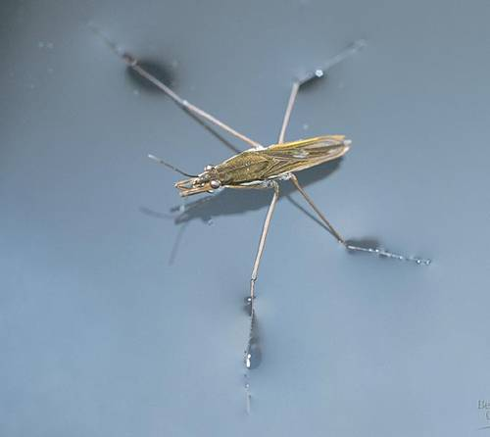

36. This image specifically demonstrates one example of how --- is beneficial to living organisms.

- Adhesion
- Surface tension
- Specific heat
- Capillary action

37. Adhesion leads to --- , which is the characteristic of water in which explains the molecular absorption of water into a root or stem of a plant.

- Adhesion
- Surface tension
- Polarity
- Capillary action

DIA Review
Topic: MacroMolecules
Station 13

38. Bears often eat large amounts of food before hibernation. In their bodies, the excess food energy is stored as solid fats, which can be used for long-term energy storage. The structure of those fat molecules most likely fits in what group?

- Carbohydrates
- Lipids
- Proteins
- Nucleic acids
- Amino acid

39. A(n) --- is a basic unit of a carbohydrate.

Monosaccharide

Starch

Nucleotide

Glycerol

Amino acids

DIA Review
Topic: MacroMolecules
Station 14

40. Which of the following nutrients is used to build and repair cells?

- Fats
- Nucleic acids
- Proteins

Carbohydrates

41. All organic compounds contain the element

- Water
- Carbon
- Oxygen
- Inorganic

DIA Review
Topic: MacroMolecules
Station 15

42. Amino acids are the building blocks for

Proteins

Steroids

Lipids

Nucleic acids
- Carbohydrates

43. Nucleotides are composed of a(an):

A. Amino acid,

B. Nitrogen-containing base,

C. Fatty acid,

D. 5-carbon sugar,

E. Phosphate molecule.

- B, D, C
- A, D, E
- C, D, E
- B, D, E
- A, B, C

DIA Review
Topic: MacroMolecules
Station 16

44. Which of the following represents the correct ranking of terms from smallest to largest?
- Macromolecule polymermonomer carbon atom
- Carbon atom  macromolecule  polymermonomer
- Monomer carbon atom  macromolecule  polymer
- Carbon atom  monomer  polymer  macromolecule

- Long chains of amino acids are found in

- Lipids
- Proteins
- Nucleic acids
- Carbohydrates

DIA Review
Topic: MacroMolecules
Station 17

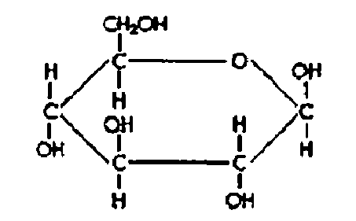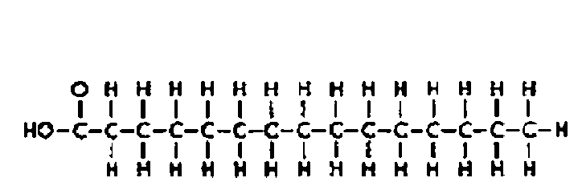
Molecule A Molecule B

- Refer to the illustration above. Molecules like Molecule “B” are found in

- Lipids
- Proteins
- Nucleic acids
- Carbohydrates

- Refer to the illustration above. Molecules like Molecule “A” are found in

- Lipids
- Proteins
- Nucleic acids
- Carbohydrate

DIA Review
Topic: Enzymes
Station 18

48. Enzymes are critical for biological reactions to occur in an organism. How do enzymes help chemical reactions to take place?

- They speed up reactions by adding more substrates
- They slow reactions down by increasing the activation energy
- They speed up reactions by lowering the activation energy
- They slow down reactions by changing the overall temperature

49. The energy needed to start a chemical reaction is called the ---.

- Reaction energy
- Activation energy
- Heat energy
- Lightning

DIA Review
Topic: Enzymes
Station 19

50. Which statement about enzymes is not true?
A. | - Enzymes are composed of polypeptide chains.
B. | - Enzymes form a temporary bond with a reactant.
C. | - Enzymes are destroyed when they are used and must be made each time a reaction takes place.
D. | - Each enzyme is specific because of its shape and catalyzes on certain reactions.

51. Enzymes
A. | - Are able to heat up molecules so that they can react.
B. | - Provide CO₂ for chemical reactions.
C. | - Are biological catalysts.
D. | - Absorb excess heat so that reactions occur at low temperatures.

DIA Review
Topic: Enzymes
Station 20

Use the graph below to answer the next two questions.
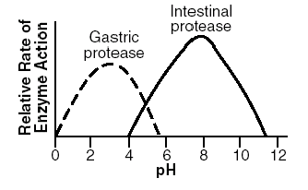

52. The contents of the small intestine have a pH greater than 7. When gastric protease (an enzyme) enters the small intestine, the activity of the gastric protease will probably
- Increase.
- Decrease.
- Increase at first, then decrease.
- Remain the same.

53. What is the optimum pH for the action of the enzyme intestinal protease?
- 5
- 8
- 10
- 12

DIA Review
Topic: Enzymes
Station 21

Refer to the following graph, which shows the energy changes during a chemical reaction that has not been catalyzed by an enzyme and the energy changes for the same chemical reaction that has been catalyzed by an enzyme.
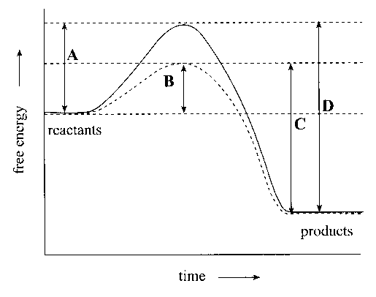

54. Which letter on the graph indicates the energy of activation for the chemical reaction that has been catalyzed by an enzyme?

  - A
  - B
  - C
  - D

55. What will most likely happen if an appropriate enzyme is added to a chemical reaction?
  - The reaction rate will increase.
  - The equilibrium of the reaction will be maintained.
  - The reaction rate will decrease.
  - The reaction will stop.

DIA Review
Topic: Enzymes
Station 22

Use the diagram and graph below to answer the next two questions.

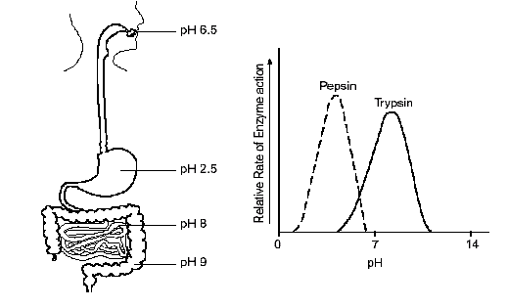

56. The diagram above indicates that the enzyme pepsin would function best in the
- Mouth.
- Stomach.
- Small intestine.
- Large intestine.

DIA Review
Topic: Enzymes
Station 23

Use the diagram and graph below to answer the next two questions.

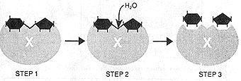

57. What do the two black hexagons in step 3 of the image above represent?

- The products
- The reactants
- The substrate
- The substrate-enzyme complex

58. The location on an enzyme where binding occurs is known as the .

- Action point
- Enzyme
- Binding location
- Active site

DIA Review
Topic: Enzymes
Station 24

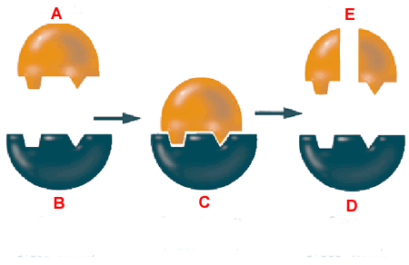

Using the image above, identify the labeled structures:

59. A-

60. B, C, D-

61. E-

62. The human body maintains a temperature of around 98.6 degrees at all times. Enzymes are involved in almost every chemical reaction in the body. Which of the following describes the connection between these two statements?

  - Enzymes function best at a specific temperature.
  - The body needs to be warm to prevent hypothermia.
  - The body is kept relatively warm to prevent too much enzyme action.
  - There is no connection between the two statements.

