Spectroscopy Lab

Name ____________________ Pd. _____ Date___________

Electromagnetic Spectrum
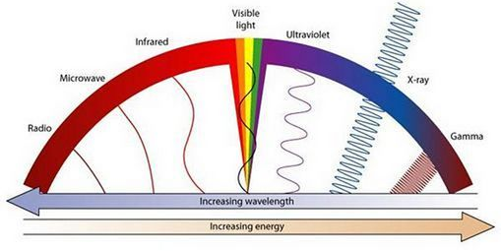
- Background:
Light enables us to see the world around us and is the only part of the electromagnetic spectrum that the human eye can see. When we look up into the night’s sky, we see stars and other objects because of the light these objects emit. Remember, planets DO NOT emit light, rather they reflect light from stars.

A spectroscope can break visible light down into its basic colors. Each element in the Universe has its own distinctive spectrum of colors – it’s a kind of unique “signature” that allows us to tell them apart. This is how astronomers are able to identify the composition, age, size, temperature, etc of objects in space.

- Directions:
In this lab you will be observing the spectra produced by different elements found on Earth and in space. For each spectrum you are shown, you are to sketch the appearance of the color spectrum. Then answer the analysis questions that follow.

Make a prediction: How similar do you think the elements will be? Will it be easy to tell them apart? Difficult?
____________________________________________________________________________________________________________________________
___________________________________________________________________________________________________________________________

Violet Indigo Blue Green Yellow Orange Red

Element #1 _________________

Violet Indigo Blue Green Yellow Orange Red

Element #2 ________________

Violet Indigo Blue Green Yellow Orange Red

Element #3 ________________

Violet Indigo Blue Green Yellow Orange Red

“Mystery Element” #4 ________________

- Analysis & Conclusions (LEFT SIDE OUTPUT):

- Describe - How were the elements different?

- Identify - Were you able to identify the “mystery element”? What was it??

- Explain – Which two elements are the most common in stars?

- Predict - Since we can’t go to the sun to study it, how do scientists know this??

- Analyze – how does viewing the spectra of an element help scientists study space?

- Compare – How does the wavelength and frequency of visible light compare to gamma rays?

