Name: __________________________________________________ Date: _______________________ Period: ______

**Cell Theory and Microscopes**

1. The cell theory was first proposed in 1838. Evidence obtained through additional scientific investigations resulted in the current cell theory. What are the three parts of the Cell Theory? (P67 in your ISN)

a. ___All living things are composed of cells_____________________________

b. ___Cells are the basic unit of structure and function in all living things_______

c. ___All cells come from pre-existing cells______________________________

_________________________________________________________________________________________________

1. What component of the original theory was changed because of new scientific knowledge?

Cells form through spontaneous generation (they come from non-living things)



1. Examine the model above. What part of the cell theory does this model support?

C – All cells come from pre-existing cells

1. Match the name of the microscope with the correct usage.
   1. Compound
   2. Transmission Electron Microscope
   3. Scanning Electron Microscope

___a____Shows a two-dimensional image of a specimen. This microscope would be used to examine the chloroplast of a living leaf.

___c____Shows a three-dimensional image of a **specimen’s surface**. Specimens do not need to be cut into slices. This microscope would be used for examining the outer surface of a plant cell.

___b____Shows a two-dimensional image of a thin slice of the specimen. Specimens must be sliced in order to view. This microscope would be used to a mitochondria’s **internal** structures in **greatest** detail.

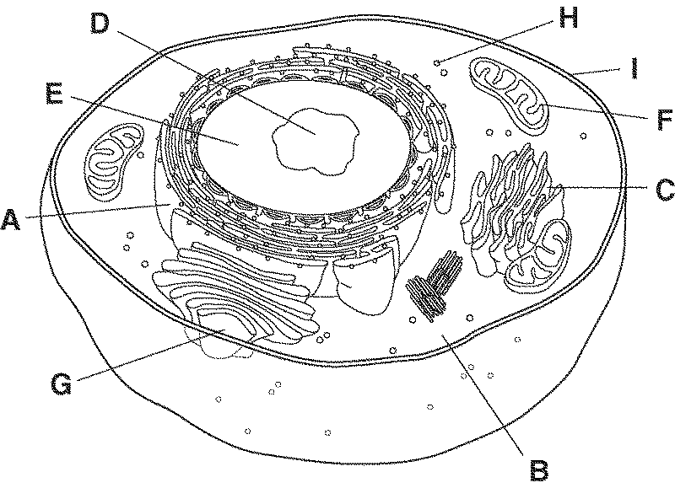**Cell Form and Function**

1. This is a **plant / animal / bacteria** cell.
2. This is a **prokaryotic/eukaryotic** cell.

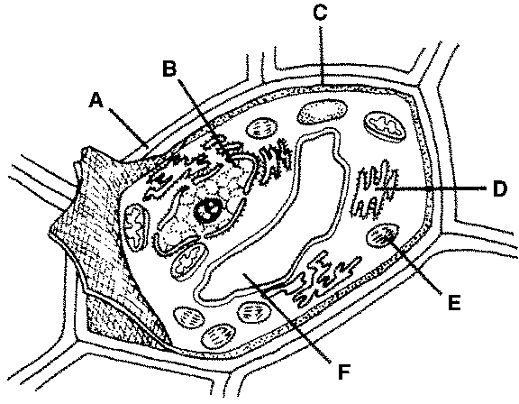

1. This is a **plant / animal / bacteria** cell.
2. This is a **prokaryotic/eukaryotic** cell.
3. 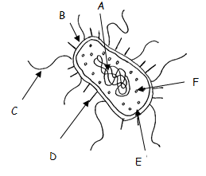This is a **plant / animal / bacteria** cell.
4. This is a **prokaryotic/eukaryotic** cell.
5. Viruses attack cells by inserting their own DNA into the host cells’ DNA. Would it be easier to for a virus to attack a prokaryotic or a eukaryotic cell? prokayotic
6. Why? Unlike eukaryotic cells, prokaryotic cells do not have a true nucleus
7. In the diagram below on the left, what are the hair-like structures called? Label it. Cilia
8. In the diagram below on the right, what is the tail-like structure called? Label it. Flagella

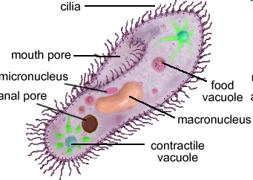 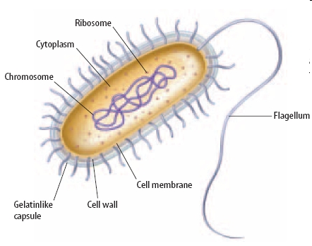

cilia

flagella

1. What is the main purpose of these structures? They move the cell from place to place in the environment



Cell wall

chloroplast

Central vacuole

mitochondria

1. Examine the diagram above. What type of cell is it? _____plant/eukaryotic________
2. How do you know? Chloroplast, cell wall, large central vacuole
3. Label the organelles/structures numbered in the diagram. see diagram
4. What are the functions of the organelles/structures you labeled?
5. ___supports and protects the cell____________________________________________
6. ___photosynthesis – energy from sunlight is converted to chemical energy____________
7. ___digests carbohydrates to produce energy, powerhouse of the cell________________
8. ___fluid-filled organelle that stores enzymes and wastes__________________________

20. Name three structures that a plant cell has that an animal cell does not.

a._Cell Wall_____ b.__Large Central Vacuole___ c. __Chloroplast____



mitochondria

nucleus

membrane

ribosome

1. Examine the diagram above. What type of cell is it? _____animal/eukaryotic________
2. How do you know? No chloroplast, no cell wall, no large central vacuole
3. Label the organelles/structures numbered in the diagram. see diagram
4. What are the functions of the organelles/structures you labeled?
5. ____Makes proteins_______________________________________________________
6. ____Allows wastes and gases to exit the cell___________________________________
7. ____Control center of the cell________________________________________________
8. ____ digests carbohydrates to produce energy, powerhouse of the cell _______________
9. Why do some organelles, such as the endoplasmic reticulum and the Golgi bodies, have a large folded structure?

Surface area is increased creating folding, protein packaging speeds up

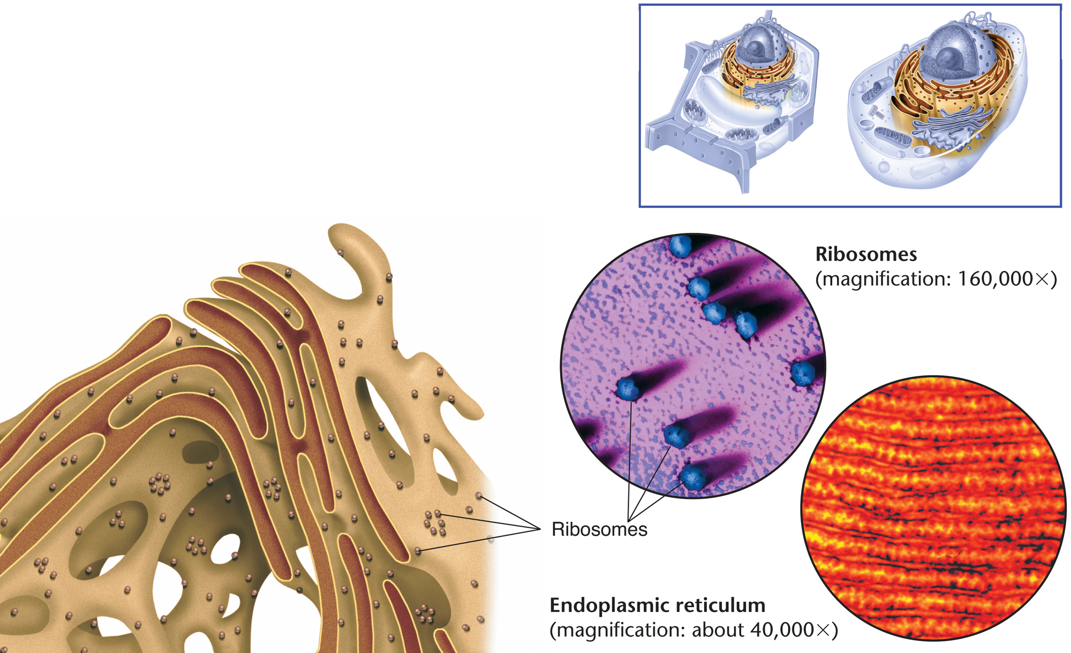 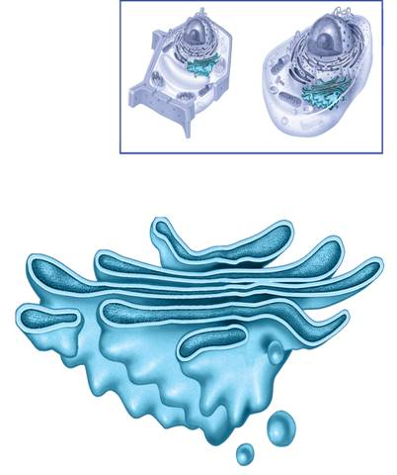

1. Some substances go through a membrane more easily than other substances. It can also determine what enters and leaves the cell. What is this characteristic of the membrane known as?
2. Impermeable
3. Selectively permeable
4. Permeable
5. Defectively permeable
6. To maintain a balance within the cell, water must move in and out. What is the process by which water moves in and out of a cell?
7. Solution
8. Solute
9. Osmosis
10. Equilibrium
11. Felicia observed that the lettuce plants in her garden had wilted after several days of drought. The next day, there was a downpour of rain and the leaves began to swell. What cellular process caused this effect in the lettuce plants?
12. Osmosis
13. Photosynthesis
14. Active transport
15. Cellular respiration
16. On the picture below determine the direction the water will move as it goes through osmosis.



1. It will move to the left



1. It will move to the right
2. It is balanced so will move freely back and forth
3. If you do not water a plant, it will eventually wilt. What happened to the cells that cause the plant to wilt?

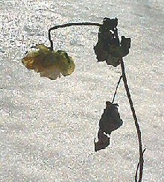

1. Increases its active transport mechanism
2. Increases turgor pressure
3. Loses active transport
4. Loses turgor pressure
5. Refer to the illustration below. What is the process being shown?
6. Diffusion

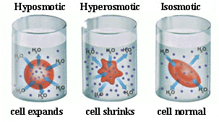

1. Osmosis
2. Endocytosis
3. Exocytosis
4. What type of **solution** is in the first beaker?
   1. Hypotonic
   2. Hypertonic
   3. Isotonic
   4. Osmotic
5. The cell membrane is composed of a lipid bilayer which is selectively permeable and allows small molecules like water to pass without problem, however, larger molecules like glucose have to pass through a protein because they are too large to get through the membrane on their own. This type of diffusion is known as?

A. Osmosis

B. Active Diffusion

C. Facilitated Diffusion

D. Isotonic Diffusion