Weather Study Guide
AIR MASS –
Continental air masses are formed over ____________________________.
Maritime air masses are formed over __________________________.
Polar air masses are formed near _____________________.
Tropical air masses are formed near __________________________.
Continental tropical | Dry, warm
Continental polar
Maritime tropical
Maritime polar

A place where two air masses meet is a ___________________________.

Scientists use ______________ and ________________________ to explain information on a weather map.
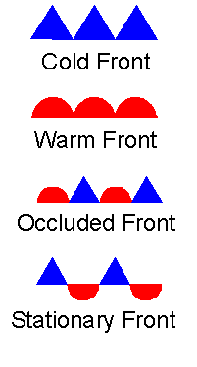
High pressure system
Low pressure system
Air moves from _____________________- pressure to ________________ pressure. This causes _____________.
- Sea breeze –
- Land breeze -

WEATHER INSTRUMENTS
____________________________ measures wind speed.
____________________________ measures wind direction
____________________________ measures temperature
____________________________measures atmospheric pressure
__________________________ is an instrument with two identical thermometers, measures humidity

HEAT TRANSFER IN THE ATMOSPHERE
RADIATION
- Energy from the sun travels to Earth as _____________________.
- Radiation – Heat transfer in the form of __________________________________ waves.
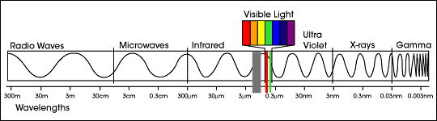

- Sun’s radiation is either ___________________________ or __________________________ .
- ___________________________ is the reflection of radiation off a surface.
CONDUCTION
- Conduction is the transfer of heat through a ___________________ .
- The air can become heated by conduction when it comes in contact with the warm Earth.
CONVECTION
- The movement of matter due to differences in density caused by temperature differences. ______________ fluids rise, ___________________ fluids sink.
- As lower layers of air are warmed, the air _______________________.
GREENHOUSE EFFECT -

Climate Study Guide
- KNOW ALL VOCABULARY WORDS.
- What are two major factors used to describe climate?
- What is topography?
- How does topography affect climate?
- What is the difference between climate and weather?
- Why does latitude affect climate?
- Why do average land and water temperatures at the same latitude vary?
- What happens when the sun heats water and land?
- What are the climate zones?
- Describe polar, tropical, and subarctic climates.
- What is ice core sampling?
- Why do meteorologists study the following:
  - Sea-floor sediment
  - Fossils
  - Tree rings
  - Speleotherms
- What are potential causes of climate change?
- What are potential impacts of climate change?
- According to the Milankovitch theory, which factors could cause climate change?
- How can you reduce co2 concentrations in the atmosphere?

