The Amazing Land of Florida

Directions: Cut out the cards and arrange them randomly. Give a set to student groups and allow them to arrange the cards accordingly.

Landform | Description | Picture Example | Landform Region
River | This landform carries and drops sediment along the coast, helping to form beaches, barriers islands, and deltas. | 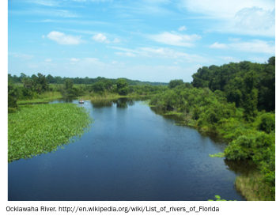 | Northern Highlands  Central Highlands  Coastal Lowlands
Ridges and Hills | These landforms run parallel to the coast and marks ancient shorelines. | 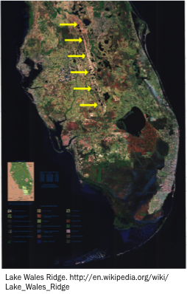 | Central Highlands  Northern Highlands
Lakes | This landform formed after erosion dissolved the limestone plateau beneath them. There are over 7,000 of this type of landform across Florida. | 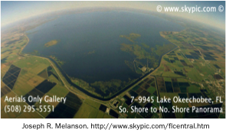 | Northern Highlands  Central Highlands  Coastal Lowlands
Wetlands | This type of landform covers several thousand square kilometers that formed on a flat block of limestone.  Shallow layer of water flows from Lake Okeechobee across the Everglades to Florida Bay. | 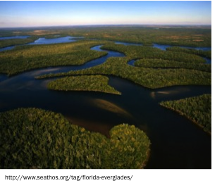 | Coastal Lowlands
Sandbars  (Coastal Features) | This type of landform is found along the coast of Florida and was shaped by Florida’s waves and currents. | 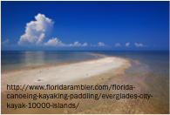 | Coastal Lowlands
Barrier Reefs  (Coastal Features) | This type of landform is found offshore of southern Florida beaches and was formed by coral colonies. | 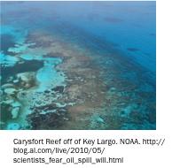 | Coastal Lowlands
©Copyright 2014- all rights reserved www.cpalms.org

