Name: ______________________________________________ Date: _______________________ Period __________
Protein Synthesis Worksheet

Part A:
- Use the DNA code to create your mRNA code.
- Use the mRNA code to create your tRNA anti-codons
- Use the mRNA code and the Codon wheel to determine your amino acids.
- Answer any questions by circling the correct answer.

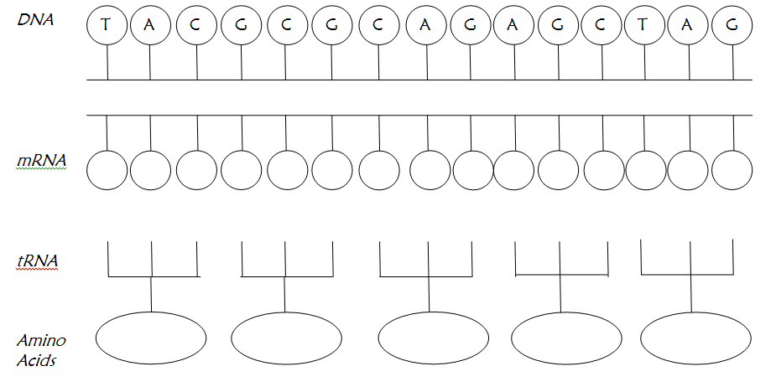

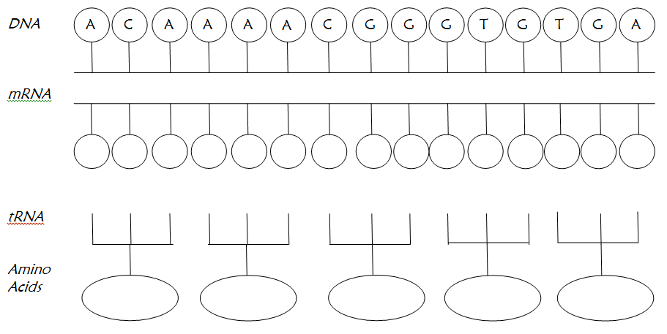
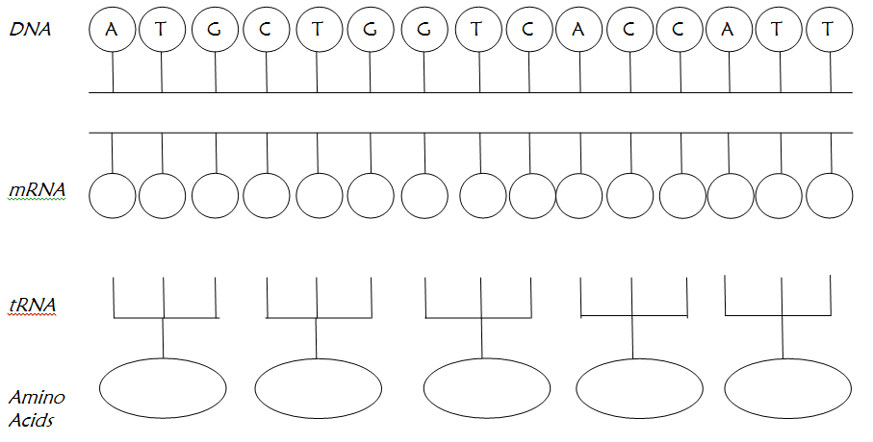

Part B: Circle the term that best completes each statement.
1. mRNA is made during (transcription/translation).

2. mRNA is made in the (cytoplasm/nucleus).

3. DNA is located in the (nucleus/cytoplasm)

4. (mRNA/rRNA) is used to carry the genetic code from DNA to the ribosomes.

5. (tRNA/rRNA) makes up the ribosome.

6. (DNA/RNA) uses uracil instead of thymine.

7. (RNA/amino) acids make up a protein.

8. Transcription takes place in the (nucleus/cytoplasm).

9. tRNA is used in (translation/transcription).

10. tRNA uses (anticodons/codons) to match to the mRNA.

11. Proteins are made at the (nucleus/ribosome).

12. (tRNA/mRNA) brings amino acids to the ribosome.

13. tRNA is found in the (nucleus/cytoplasm).

14. (Translation/Transcription) converts mRNA into a protein.

15. Translation takes place in the (cytoplasm/nucleus).

16. (DNA/RNA) can leave the nucleus.

17. (Translation/Transcription) converts DNA into mRNA.

