What can Rubber Duckies tell us about our oceans?
http://www.mnn.com/earth-matters/wilderness-resources/stories/what-can-28000-rubber-duckies-lost-at-sea-teach-us-about-
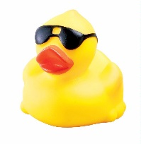
- List 4 shores that the duckies have washed up on.

- What is the vortex of currents which stretches between Japan, southeast Alaska, Kodiak and the Aleutian Islands named? What is it called today? How did the ducks help identify its existence?

- How many major gyres do we know exist today across the world’s oceans?

- Describe the Great Pacific Ocean Garbage Patch.

- How many shipping containers do oceanographers estimate are lost at sea every year?

What can Rubber Duckies tell us about our oceans?
http://www.mnn.com/earth-matters/wilderness-resources/stories/what-can-28000-rubber-duckies-lost-at-sea-teach-us-about-
1. List 4 shores that the duckies have washed up on.

2. What is the vortex of currents which stretches between Japan, southeast Alaska, Kodiak and the Aleutian Islands named? What is it called today? How did the ducks help identify its existence?

3. How many major gyres do we know exist today across the world’s oceans?

4. Describe the Great Pacific Ocean Garbage Patch.

5. How many shipping containers do oceanographers estimate are lost at sea every year?

